CATTLE HEALTH MONITORING SYSTEM
USING MACHINE LEARNING

PRESENTED BY: Rithin P. Vali
Dept. of CS&E
JIT, Davanagere, India

GUIDED BY: Dr .Azizkhan F. Pathan
Associate Professor
Dept. of CS&E
JIT, Davanagere, India.

ABSTRACT --- Cattle health monitoring is a critical aspect of livestock management that ensures the overall health and productivity of the herd. With the emergence of machine learning technology, it is now possible to monitor the health of cattle without relying on IoT devices. Machine learning-based systems can analyze various factors such as weight, temperature, and behavioral patterns of the animals to identify potential health issues. The system can also analyze the data collected over time to detect patterns and trends that could indicate long-term health issues. Furthermore, Machine learning-based cattle health monitoring systems can also help identify and predict the onset of diseases and recommend appropriate treatment options. This can help farmers to take proactive measures to prevent the spread of diseases and minimize the risk of losses. Overall, Machine learning-based cattle health monitoring systems have the potential to revolutionize livestock management by providing accurate and reliable insights into the health and well-being of the animals without relying on IoT devices.
Keyword- cattle health monitoring, machine learning, IoT, livestock.

Introduction
All areas have seen an increase in the impact of technology in recent years and the ongoing trend towards digitization. Parts of almost every field have been digitalized to facilitate more effective and simple management. The field of agriculture, with a focus on keeping tabs on the health of cattle, is one of the areas that is being digitised and is a component of the research and subject of the current study. State organizations around the world have made significant investments in digitization in this sector to ensure greater productivity for farmers. According to the World Government Summit agenda [1], 650 million people will still be undernourished by 2030, accounting for 8% (or 800 million) of the global population. The same analysis states that because of rising demand, we would need to produce 70% more food by 2050.
The primary pillars of economic development in every country in the world, including Kosovo, are industry, services, and the agricultural sector. The most recent data issued by the Ministry of Agriculture, Forestry, and Rural Development states that the agriculture sector provides 8.1% of Kosovo's GDP [2]. The same study states that Kosovo recorded 257,733 cattle in 2019, down 929 heads from 2018, including calves, appetisers, heifers, bulls, dairy cows, and beef cattle. Cows under the age of one year made up 32% of the population, those between one and two years made up 10%, and those over two years made up 58%. The largest significant group of livestock is cattle, which accounts for 47.5% of all livestock heads [3]. According to [3], the overall stock of cattle increased by 1.4% in 2020 when compared to the previous year. Compared to 2019, there was a reduction in the majority of categories, with the exception of female calves under a year old, calves between one and two years old, and other cows. The total number of cattle was 261,379 in 2020. The same analysis estimates that dairy cows will account for 51% of all cattle by 2020. Due to a higher number of dairy cows, the total milk production in 2020 was 281 thousand tonnes, which is around 2% more than in 2019. At EUR 29.4 million, the trade balance remained negative. The amount of food consumed per person was 170 kilogrammes per year, or roughly 0.5 kg per day, including milk and its byproducts.
Cattle health monitoring is an important aspect of livestock management that involves the continuous assessment of animal health and welfare. Traditionally, cattle health monitoring has been performed through visual observation and manual data recording, which can be time-consuming, labor-intensive, and prone to errors. With the emergence of artificial intelligence (AI) technology, there is now an opportunity to revolutionize cattle health monitoring by automating the process and providing accurate and real-time insights into animal health and welfare. AI-based systems can analyze various factors such as weight, temperature, and behavioral patterns of the animals to identify potential health issues, and can also help identify and predict the onset of diseases and recommend appropriate treatment options. In this way, AI-based cattle health monitoring systems have the potential to improve the overall health and productivity of the herd while reducing the risk of losses and improving animal welfare.

BACKGROUND & LITERATURE REVIEW
The use of machine learning in livestock management is a relatively new field that has gained attention in recent years. With the increasing demand for food and the need to optimize livestock productivity, there is a growing interest in using machine learning to monitor and manage animal health and welfare.
A brand-new Internet of Things (IoT)-based system for monitoring livestock was unveiled by Unold et al. [4] and is intended to automate measurements of the health status of dairy cows in a traditional loose housing cowshed. This study claims that they created a system that could track dairy cow behavior and allow them to identify a certain physiological condition.
For the purpose of tracking various diseases in dairy cattle, Sharma et al. [5] introduced a variety of wireless sensor network (WSN)-based autonomous health-monitoring systems. In this work, they reviewed the different low-power and low-cost sensor node-based animal monitoring systems that are currently available.
For a cow health monitoring system, Suresh et al. [6] presented a system that included data collection, mobile nodes, and an IoT cloud platform. They claim that the system architecture supports the data-gathering nodes' ability to scale, which is crucial for real-world deployment.
A cloud IoT-based livestock management system with three features was presented by Saravanan et al. [7] The features included animal-healthcare monitoring and recording using IoT sensors via a wearable collar, animal livestock identification using UID for animals, and QR code reading, processing, and display of the information via wireless technology.

Methodology
Figure 1 shows the Methodology of Cattle Health Monitoring using Machine Learning.

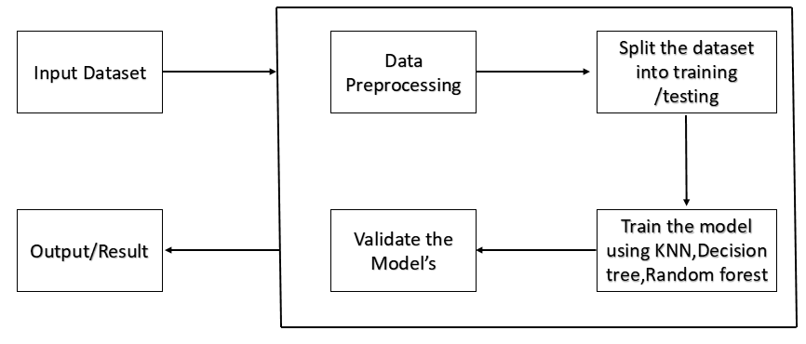
Fig.1. Methodology of Cattle Health Monitoring using Machine Learning
The different steps involved in the Cattle Health Monitoring using Machine Learning are:
- Input Dataset: The input dataset for cattle health monitoring using machine learning includes body weight, body temperature, behavioral patterns, milk production, heart rate and respiration rate, reproductive health, and environmental factors such as temperature, humidity, and air quality. These factors can be collected through sensors attached to the animal or through manual data recording.
- Data Preprocessing: Data preprocessing for cattle health monitoring using machine learning involves collecting data using sensors or manual recording, cleaning the data by removing noise and imputing missing values, normalizing the data to a common scale, and extracting relevant features for training the AI-based system.
- Split Data into Train and Test: Splitting data into a training set and testing set involves randomly selecting a portion of the data as the testing set and the remaining data as the training set. This is done to evaluate the performance of the machine learning model on unseen data. The percentage split may vary depending on the size of the dataset and the complexity of the machine learning model. It is important to ensure that the data is split randomly and that both the training set and testing set have a representative distribution of the input features and target labels.
- Model Training: The next step in developing a machine learning-based cattle health monitoring system is to train the model using machine learning algorithms such as KNN, Decision Tree, and Random Forest. KNN works by finding the K-nearest data points to the input data point and predicting the output label based on the most common label among the K-nearest neighbors. Decision Tree works by recursively splitting the data into subsets based on the most informative feature, while Random Forest works by creating multiple Decision Trees and aggregating their predictions.
- Model Validation: The Model validation involves evaluating the performance of the machine learning model on the testing set by comparing its predictions to the actual target labels. Metrics such as accuracy, precision, recall, and F1-score can be used to measure the performance of the model. It is important to ensure that the model is not overfitting the training data and that it generalizes well to unseen data. Cross-validation techniques such as k-fold cross-validation can be used to further validate the model's performance.
- Output: The output includes a prediction or classification of the health status of individual cattle or the entire herd based on input data such as weight, temperature, and behavior patterns. The output may also include recommendations for appropriate treatments or interventions based on the predicted health status of the cattle. Additionally, the system may provide visualizations or reports of the data to help farmers make informed decisions about the management of their livestock.

RESULTS
Figure 2 shows the confusion matrix of Random Forest algorithm.
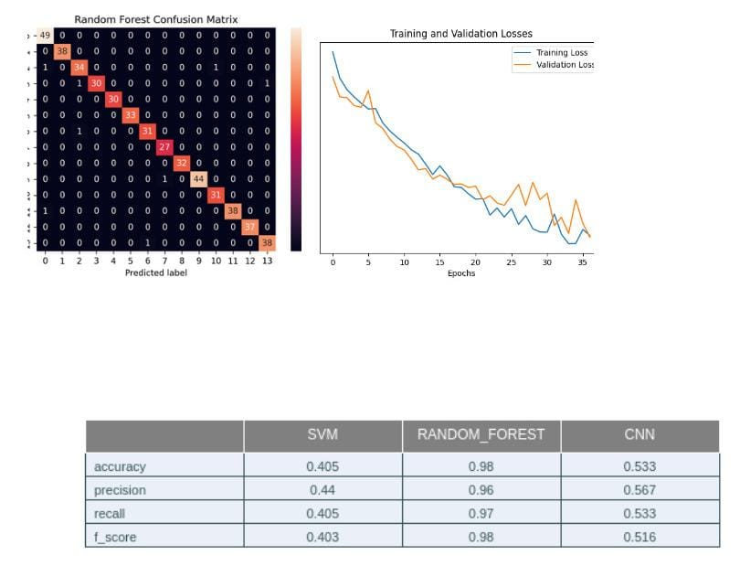

Fig. 2. Random Forest Confusion Matrix
Figure 3 shows the training vs. validation losses of random forest algorithm.

Fig. 3. Training and Validation Losses
Figure 4 shows the input blocks for the user to enter the cattle health condition values.
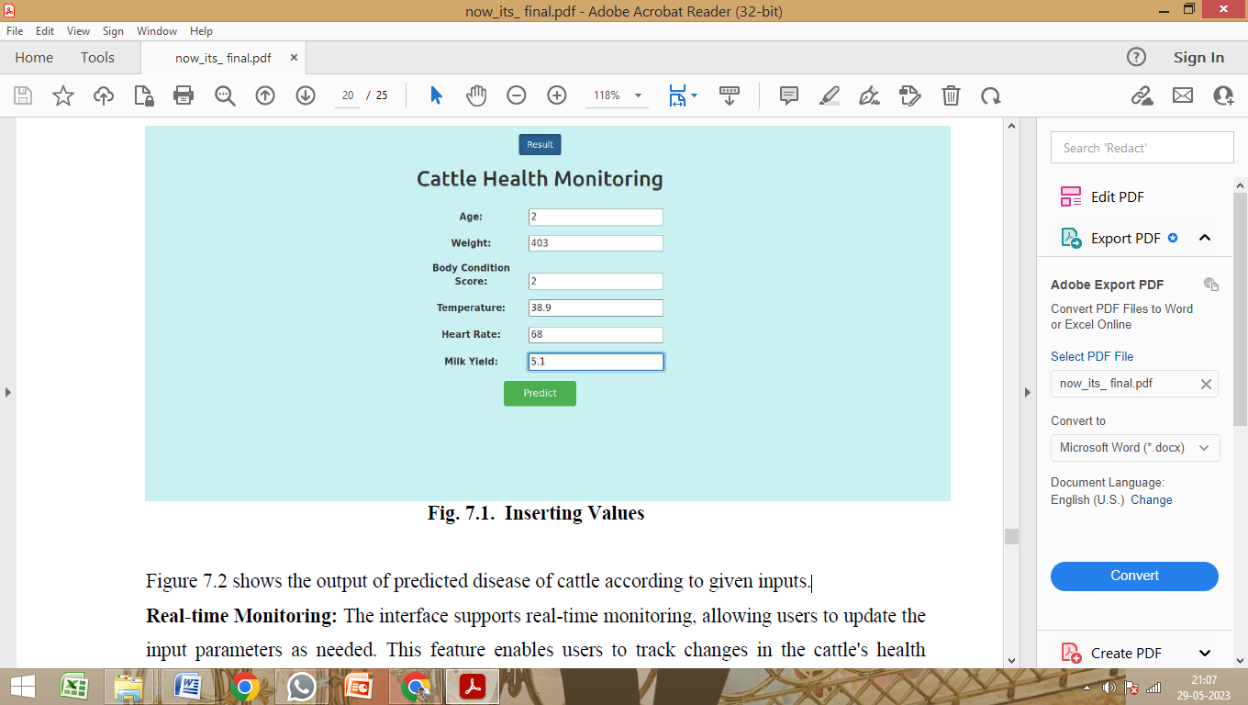
Fig. 4. Inserting Values
Figure 5 shows the output of predicted disease of cattle according to given inputs.
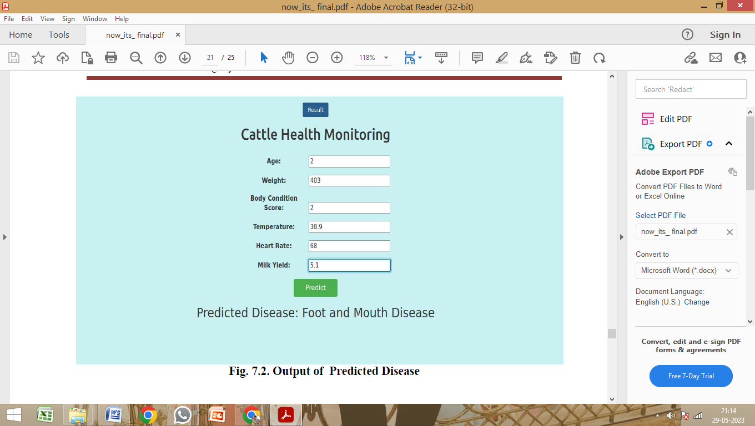
Fig. 5. Output of Predicted Disease

CONCLUSION
The use of machine learning in cattle health monitoring has the potential to revolutionize livestock management by providing accurate and reliable insights into the health and well-being of the animals without relying on IoT devices. By leveraging machine learning algorithms such as KNN, Decision Tree, and Random Forest, AI-based livestock health monitoring systems can analyze various factors such as weight, temperature, and behavioral patterns of the animals to identify potential health issues. These systems can also help identify and predict the onset of diseases and recommend appropriate treatment options. However, the success of an machine learning-based cattle health monitoring system relies on the quality and quantity of the input dataset, as well as the performance and validation of the machine learning models used. It is important to ensure that the system is not overfitting the training data and that it generalizes well to unseen data. Cross-validation techniques such as k-fold cross-validation can be used to further validate the model's performance.
Overall, the development of machine learning-based cattle health monitoring systems has the potential to greatly benefit the livestock industry by improving the health and productivity of cattle, reducing the risk of losses, and enabling farmers to make informed decisions about the management of their livestock.

REFERENCES
[1] De Clercq, M.; Vats, A.; Biel, A. Agriculture 4.0: The future of farming technology. In Proceedings of the World Government Summit, Dubai, United Arab Emirates, 11 February 2018.
[2] Green Report 2020. Available online: https://www.mbpzhr-ks.net/repository/docs/Raporti_i_Gjelber_202003022021.pdf
(accessed on 16 January 2022).
[3] Green Report 2021. Available online: https://www.mbpzhr-ks.net/repository/docs/Raporti_i_Gjelber_2021.pdf (accessed on 16 January 2022).
[4] UnoldS, O.; Nikodem, M.; Piasecki, M.; Szyc, K.; Maciejewski, H.; Bawies, M.; Dobrowolski, P.; Zdunek, M. IoT-Based Cow Health Monitoring System. In Computational Science—ICCS 2020; Springer: Cham, Switzerland, 2020.
[5] Sharma, B.; Koundal, D. Cattle health monitoring system using wireless sensor network: A survey from innovation perspective. IET Wirel. Sens. Syst. 2018, 8, 143–151.
[6] Suresh, A.; Sarath, T.V. An IoT Solution for Cattle Health Monitoring. IOP Conf. Ser. Mater. Sci. Eng. 2019, 561, 012106. [CrossRef]
[7] Saravanan, K.; Saraniya, S. Cloud IOT based novel livestock monitoring and identification system using UID. Sens. Rev. 2018, 38,1.

